**CURRICULUM VITAE**

**PUSPALATA BEHERA** 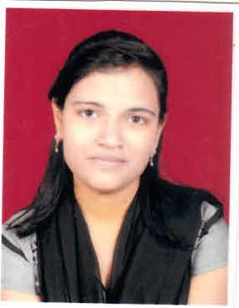

**MOB- +91 - 8658384653**

CAREER OBJECTIVE

To pursue a career in your esteemed organisation as an efficient employee and utilizing my skills to add to the development of the organisation and contribute to the prosperity of the organisation.

**EDUCATIONAL QUALIFICATION**

* 10th, Upper kolab project High School, Jeypore, Odisha, (HSCE ODISHA),

Percentage of Marks 81.58%(passout in 2012)

* 12th, Vidwan’s Institute Of Basic Studies, jeypore(Koraput), Odisha. (CHSE BOARD)

Percentage of Marks 58.88%(passout in 2014)

* +3 (B. Sc Computer Science), Vikram Deb Autonomous College, Jeypore, Odisha (Berhampur University). Percentage of Marks 65.11% (passout in 2017)
* BSc. B.ed, Acharya Nagarjuna University, Andhra Pradesh, Passout 2020, Percentage- 82.58%

**Working Experience Detail-:** Organisation Name-People’s Forum , One Stop Centre – Sakhi , S.L.N Govt. Medical College and Hospital , Koraput, ODISHA.(Current Job)

**Designation**-IT Assistant.

**Date Of Joining** – 19-09-2018.

**Working Role** – Case registering on Dashboard to generate Unique ID of the Survivor,

Preparing Presentation On this project for submission in seminar.

In charge of the centre in the absent of Centre Administrator.

Handling all the data about case related which could be Saved by confidential manner.

Reporting annual report.and managing all data entry & important mail interaction.

Preparing & Sending Monthly Progress Report, Quarterly Progress Report and Other kind of report as per the communication of state and central department.

Other Database management with mail drafting , Email communication and Other application of the System.

**Professional Skills**

* Programming language: C, C++,javaDear Sir/Madam,
* Operating system: DOS, UNIX, Win (7, 8, 10)
* Network Administration, Computer Networks,HTML, Programming knowledge,Database management system, Data structure.
* MS Office – Word, Excel and PowerPoint.
* PGDCA in computer application with Hardware Networking knowledge.

**Extra-Curricular Activities**

**Hobbies**

* Creative writing
* Listening to music
* Reading Current afairs

PERSONAL PROFILE

* Name : Puspalata Behera.
* Date of Birth :24 Jun,1997
* Father’s Name : Sri. Padmalochana Behera.
* Mother’s Name : Smt. Jayanti Behera.
* Gender : Female
* Nationality : Indian
* Permanent Address : D/o – Sri Padmalochana Behera

At – Lingrajnagar street

Po – Jeypore

Dist – Koraput

Pin - 764001

* Email id : puspabehera180@gmail.com
* Alternate No. : +91-6371558062
* Date
* Place

(PUSPALATA BEHERA)